Ansible Infrastructure Management Tool

Create a EC2 instance with name

ansiblemanagementController

sudo apt-add-repository -y ppa:ansible/ansible

sudo apt-get update

sudo apt-get install –y ansible

ansible --version

ansible 2.8.0

config file = /etc/ansible/ansible.cfg

configured module search path = [u'/root/.ansible/plugins/modules', u'/usr/share/ansible/plugins/modules']

ansible python module location = /usr/lib/python2.7/dist-packages/ansible

executable location = /usr/bin/ansible

check

cd etc/ansible

get hosts,ansible.cfg.roles

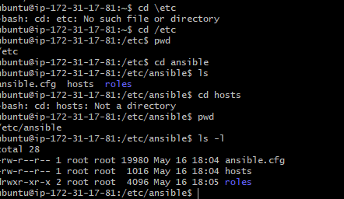

Sudo vi hosts

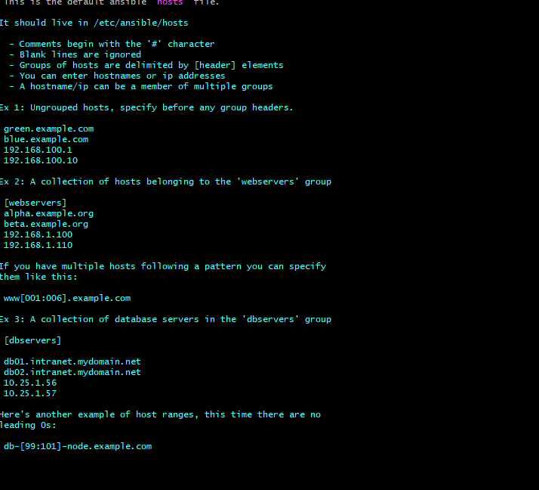

~ ansible-doc –l

~ ssh-keygen

Then go root dir

~cd .ssh

List of file like

~ id_rsa.pub

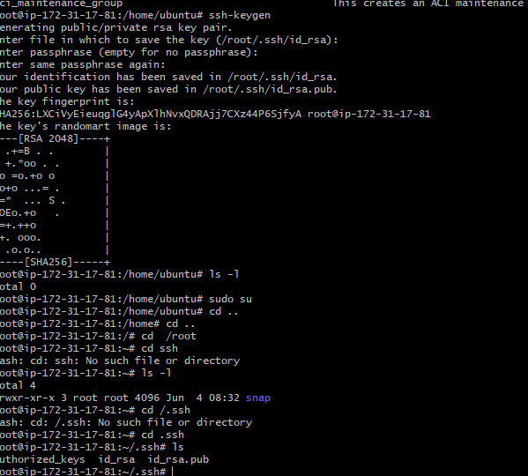

To copy key form one ip to another ip

Ssh-copy-id 172.31.31.214

` then go to authorized_keys

~sudo vi authorized_keys

Place all the client_host ssh key in id_rsa.pub to connect with ansibleamnagementController

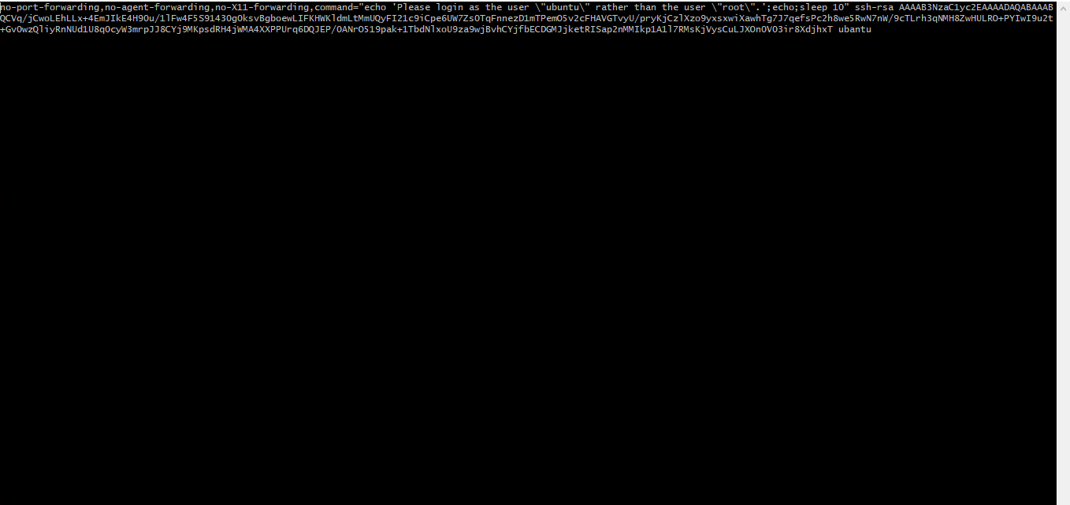

Sudo vi id_rsa.pub in ansible controller

Copy client_host id_rsa.pub file ip address to master

So now client_host ip connected to master

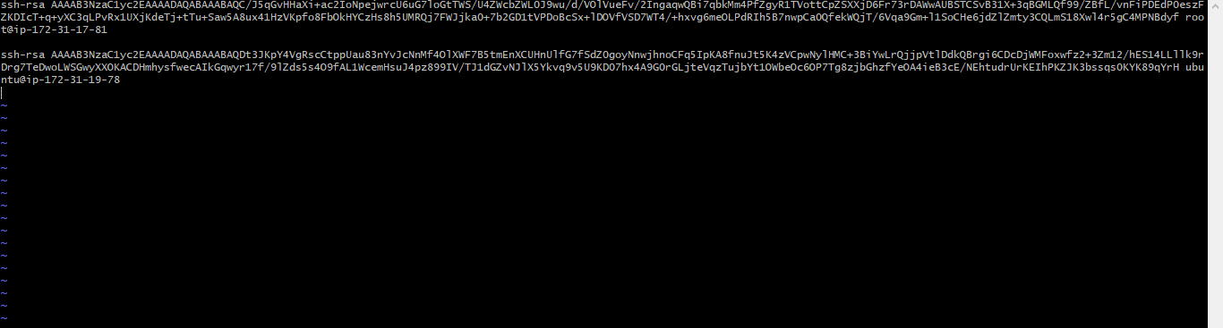

How to check the server working fine or not ?

Ansible group name –m ping

Ansible batch25 –m ping

How to check the client data in server ?

Ansible batch25 –a “ls –l /opt”

How to copy file for server to client server ?

Ansible batch25 –m copy –a “src=/opt/file1 dest=/opt”

Ansible batch25 –m copy –a “src=/opt/file1 dest=/opt” -s

How to check the git software install in client server ?

Ansible batch25 –a “git”

How to remove the git software in client server ?

Ansible batch –m yum –s –a “name=git state=absent”

Absent =remove

Latest=install latest version

Present=install present version

How to execute multi commands in single command ?

Ansible batch25 –m shell –a “ls –l /opt;hostname;df”

How to install packages using playbook ?

How to install http packages install in clientserver ?

Ansible batch25 –m yum –s –a “name=httpd state=present”

Once install the httpd packages and how to start the services ?

Ansible batch25 –m service –s –a “name=httpd state=started”

Stoped

Restarted

How to create the user in client server ?

Ansible batch25 –m user –s –a “name=devapps”

How to create the playbook ?

Vi devapps.yml

---

-hosts : batch 25 (ot) ALL

Become: yes

Tasks:

-name: installing httpd

Yum: name=httpd state=latest

-name: starting httpd services

Service: name=httpd state=started

-name: copy file

Copy: src=/opt/test.html dest=/opt/test

How to execute the yml code ?

Ansible-playbook devapps.yml

How to execute multiple packages using yml code ?

---

-hosts : batch 25 (ot) ALL

Become: yes

Tasks:

-name: installing httpd,git,wget…..

Yum: state=latest name= {{item}}

With_items:

-git

-httpd

-wget

-name: services httpd,git,wget…..

Yum: state=started name= {{item}}

With_items:

-git

-httpd

-wget